1. Cut out the words
2. Paste in the correct section
3. When dry, color the picture

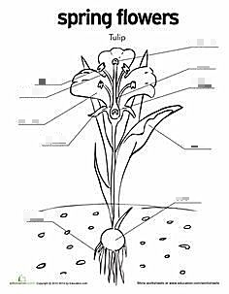

|  |  |  |  |  |
| --- | --- | --- | --- | --- |
| Anther | Petal | Stamens | Stepals | Stigma |
| Pistils | Ovary | Leaf | Bulb | Roots |

Name: ______________________________

Tulips

Directions: Write three facts about Tulips.

1. ______________________________________________________________________________  
     
   __________________________________.
2. ______________________________________________________________________________  
     
   __________________________________.
3. ______________________________________________________________________________  
     
   __________________________________.

Directions: In the box draw a picture of Tulips.